Customer Review Analysis

First Year Under New Management

Gaurav Badhan

Introduction:
Touch of East is a beauty and wellness business, encompassing traditional and modern techniques to provide customers with high-quality services, such as threading, waxing, facials, nails and massages. Following a change in management and ownership, the business has just celebrated its first anniversary under the new owners. The customer review analysis aims to evaluate the feedback received under the new mangament, to see how well the customers feel under the new management and highlight the strengths and weaknesses of the business.

Methodology:

The data was collected from Google reviews published by customers after their treatments and appointments. The reviews cover the period from August 2024, when the buisness went under new management, until August 2025. There were a total of 101 reviews under this period; after removing empty reviews (NA), the dataset was reduced to 84 reviews.

This analysis was performed using Python, utilising the NLTK library to tokenise, and remove stopwords and punctations to ensure the analysis focuses on meaningful word, this included additional words common to the trade and business in a text document. After the pre-processing using the same library I stemmed the data to remove suffixes and prefixes, to get the basic word.

Following the pre-processing, sentiment analysis was performed to classify whether each review was positive or negative. This allowed for a quantitative assessment of the customer satisfaction during the first yeat of new management. TextBlob libary was used to calculate the polarity and then using the this categorise it for further analysis, where a ploarity of 0.3 or greater is positive, otherwise it was negative. Subjectivity was not included in the analysis, as all reviews were assumed to reflect customer’s opinions.
Analysis & Results:
Sentiment Distribution:

Out of the 87 reviews analysed, the majority expressed positive sentiment. Approximately 96.6% (84) of the reviews were classified as positive, while the other 3.4% (3) was classified as negative (Figure 1). This suggests that the overall customer satisfaction during the first year was extremly high, and that little to no improvements are required.
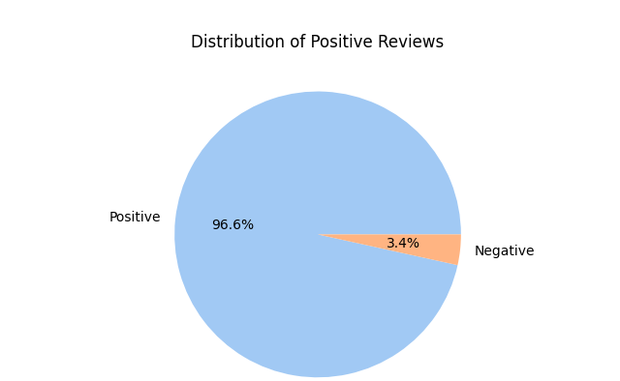

Figure 1 : Distribution of Positive & Negative Customer Reviews

Average Ratings:

The average star rating across all reviews was 4.85 out of 5. This highlight majority of the customers were satisfied with their experience, with only a small number of low ratings slightly reducing the average down. (Figure 2)
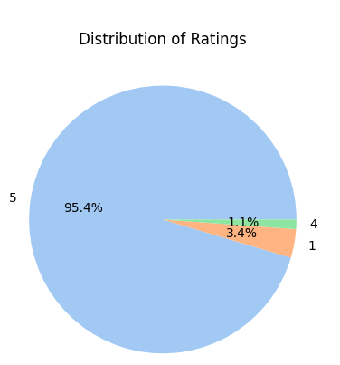

Figure 2: The Distribution of the star ratings across reviews

As shown above, the majority of customers awarded Touch of East the highest rating of 5 Stars, with a small proportion giving 1 star. Only a very small number of revies were rated at 4 stars. The distributon indicates that most customers had highly positive experience under new mangement, with only a few low rating, highlighting little areas of improvement.

Ratings & Polarity Analysis:

The initial analysis showed there were no strong correlation between the polarity scores and customer ratings (Figure 3 & Figure 4), suggesting that though the customers may have used positive or negative language within their ratings, they did not align consistently. To address this issue I decided to normlaise both the polarity and rating and combine it into a single metric, which allowed for a more strong correlation between the values, providing a clearer picture of overall customer sentiment. (Figure 4 & Figure 5)

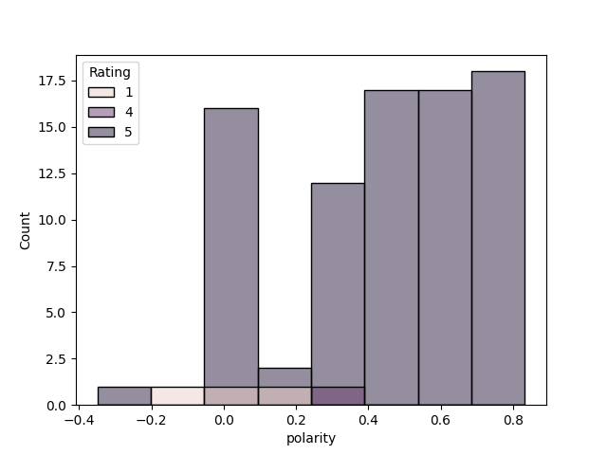

Figure 3: Histogram of original polarity scores and Star ratings

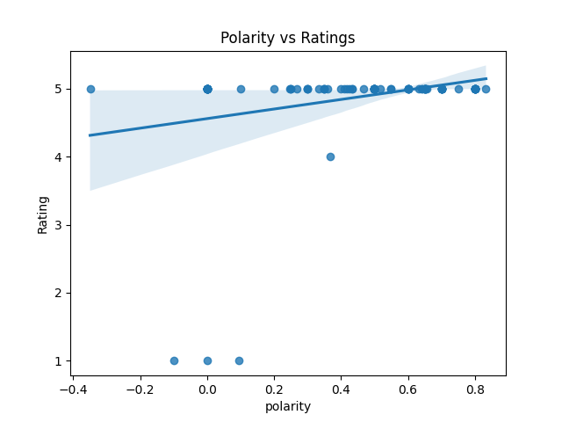

Figure 4: Scatter Plot of polartiy scores VS Star rating (showing a weaker correlation)

As shown in Figure 3 and 4, the polarity scores are widely dispersed and do not consistently align with the custoemr star ratings. Thus suggesting the sentiment does not reliaby refelct overall customer satisfaction.

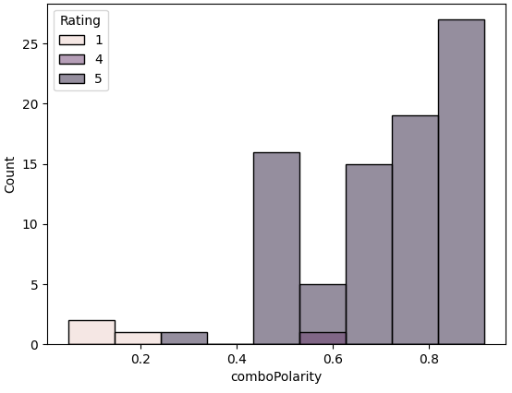

Figure 5: Histogram of Combined Polairty and Rating

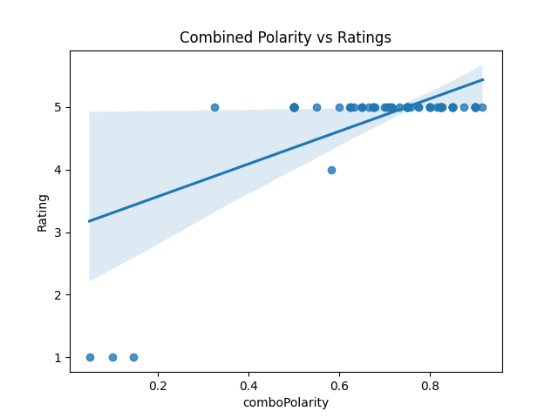

Figure 6: Scatter plot of the Combined Polairty VS Star Ratings (Shwoimg a Stronger Correlation )

As shown in Figure 5 & 6, the combined polarity is more closely grouped together, still with a few outlier. The points display a stonger correlation compared to the original polarity scores. Showing that the language in the reviews written line up with the rating given by the customer.

Positive Review Analysis:

Using a word cloud (Figure 7), the most frequent words used in the positive reviews. Most frequent words include “friendly”, “love”, “staff”, and “great”. Notably, “staff” appeared in 100% of the reviews, while “friendly” around 91% of the reviews. This highlights that the customer constanlty praised the team, suggesting they felt welcomed and valued while getting their treatments. The reviews emphasises the strong communcation skills, professonalison, and high quality service.
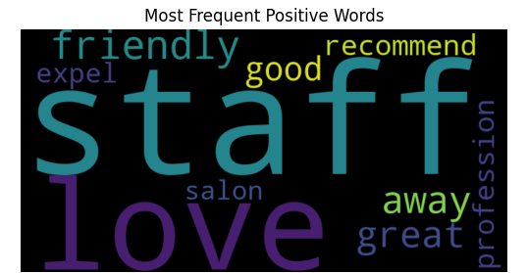

Figure 7: Word Cloud of the Top 10 words in the Postive Reviews

The top 10 positive words reinforce the fact the clients and customers of the business, rate the professionalism and care of the staff under the new management.

Negative Reviews Analysis:

Due to the relatively small number of negative reviews, the most frequent words provided limited information about the customers expereicnes and the issues. These reviews are mostly isolated experiences, rather than consistent issues and problems across the dataset. The most common word was “never” which appeared 80% of the time. These comments generally related to individual incidents where customers stated they would “never return”. Additionally, these reviews were posted early under the new management, while the other reviews are positive and often recommended and praised the business.
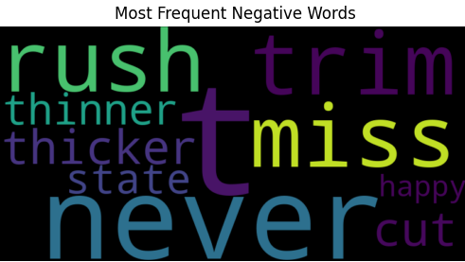

Figure 8: Word Cloud of the Top 10 words in the Negative Reviews

Conclusion:

The customer review analysis for Touch of East during the fisrt year under new management has revealed exceptional amount of psoitive feedback. With the average rating being 4.85 out of 5, and only being diminshed by a few isolated incidents.

Sentiement analysis showcased that the polarity alone didn’t correlate with stat rating, however after normalisng and combining the polarity with ratings into a single metric, a stronger correlation, but grouping the ratings closer together.

Overall, the findings suggest that Touch of East has established a strong level of customer satisfaction under the new management, where it highlighted the staff professionalism and client care. There were minor issues that appear to have been resolved, resulting in highly positive feedback in a majority of cases.

